**1.a)** SELECT *

FROM [Sales].[SalesTerritory]

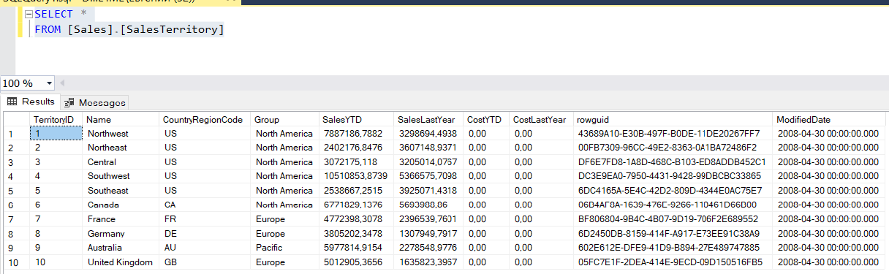

**b)** SELECT TerritoryID, Name

FROM [Sales].[SalesTerritory]

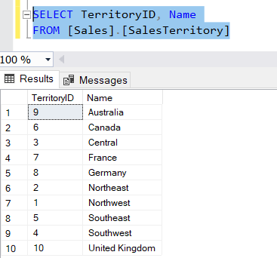

**c)** SELECT *

FROM [Person].[Person]

WHERE LastName='Norman'

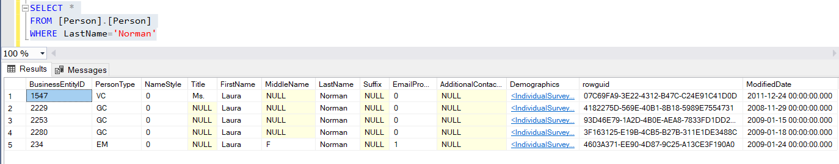

**d)** SELECT *

FROM [Person].[Person]

WHERE EmailPromotion !=2

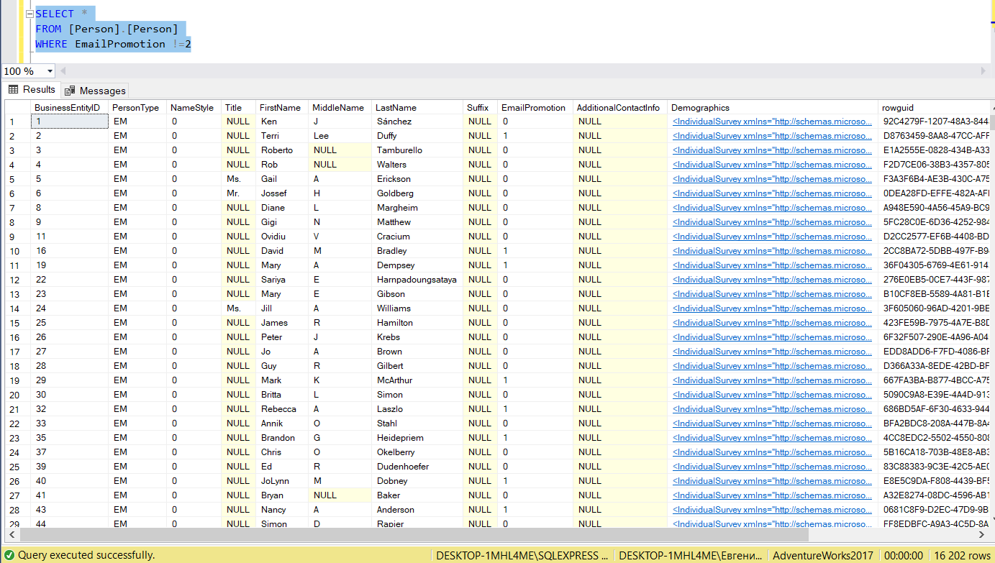

**3.** APPROX_COUNT_DISTINCT

CHECKSUM_AGG

COUNT_BIG

GROUPING

STDEV

VAR

**4. a)** SELECT COUNT (DISTINCT PersonType)

FROM [Person].[Person]

WHERE LastName LIKE 'M%' OR EmailPromotion NOT LIKE '%1%'

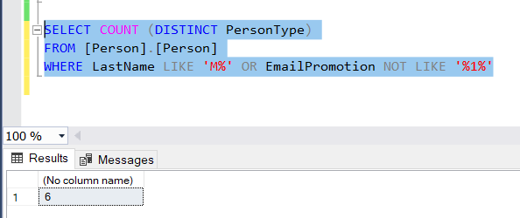

**b)** SELECT TOP 3 *

FROM [Sales].[SpecialOffer]

WHERE [StartDate] BETWEEN '2013-01-01' AND '2014-01-01'

ORDER BY [DiscountPct] DESC

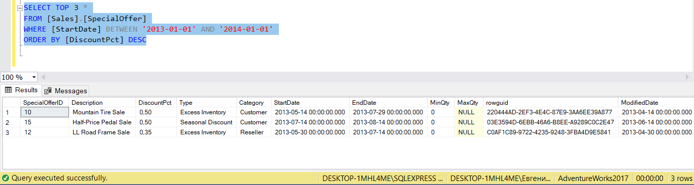

**c)** SELECT MIN(Weight) AS Минимальный_вес

FROM [Production].[Product]

SELECT MAX(Size) AS Максимальный_размер

FROM [Production].[Product]

